Vernier Calipers:
Formula: reading = MSR + VSR × Least Count of Vernier Caliper
note that the VSR is unit less since it is being multiplied by the least count.
Zero Error: It is a systematic error. There are two kinds of zero errors in vernier calipers
- +ve zero error: when the zero of VS is ahead of the zero of the MS
- –ve zero error: when the zero of VS is behind the zero of the MS
In both cases, the value of zero error will be the reading of the vernier caliper (i.e. = MSR + VSR × Least Count of Vernier Caliper). In case of –ve zero error, we will take the MSR as -1. In case of +ve zero error, the MSR will usually only be 0, but for very poor quality vernier calipers the MSR can also be 1.
Zero Correction: it is given by –ve of Zero Error in the Vernier Caliper
Different types of Vernier:
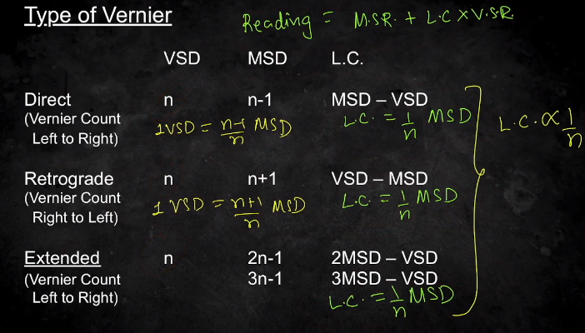
Extended Vernier calipers have more gap b/w consecutive VSDs and hence they are more clearly visible.
Double vernier is another kind of vernier scale which can be used in both directions; it gives the readings in the same way as other verniers.

However, we need not rely on these formulas since the distance moved by the vernier scale from its initial position is our required reading. Thus, do not rely of formulas to calculate reading, just use length of parallel lines equal to calculate the reading of the vernier caliper.
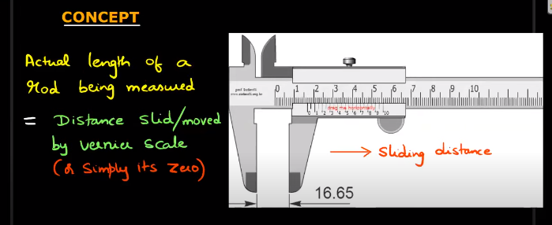
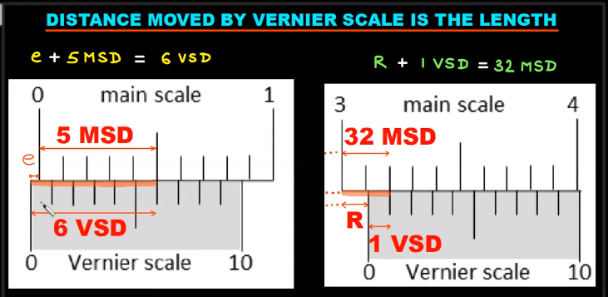
where,
e=zero error and
R=reading of the vernier caliper
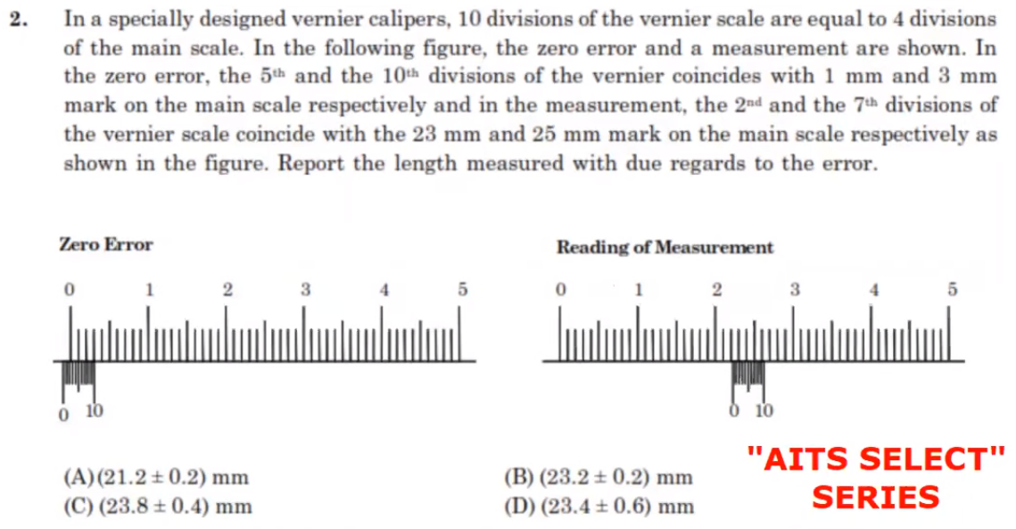
Note that the error mentioned in the form of ± is always the random error. If multiple readings are taken and then the random error is asked, calculate mean absolute error. If a single reading taken and then the random error is asked, the error would be least count error of the instrument used. Least Count Error is equal to the least count of the instrument used.
The reading obtained from the error would/should include the systematic error (the zero error). Thus, remember that the zero error is included with the reading of the experiment and comes in only 1 sign, either + or -; but a random error doesn’t have a direction.
In some questions (like the one above), there can be multiple coincidences too; like here 4 MSD=10 VSD or every 2 MSD=5 VSD. The case can be reduced to a simpler co-prime one by repeatedly dividing the scales with their GCDs until two co-primes are obtained.

# Calculating the Least Count for a general Vernier Caliper:
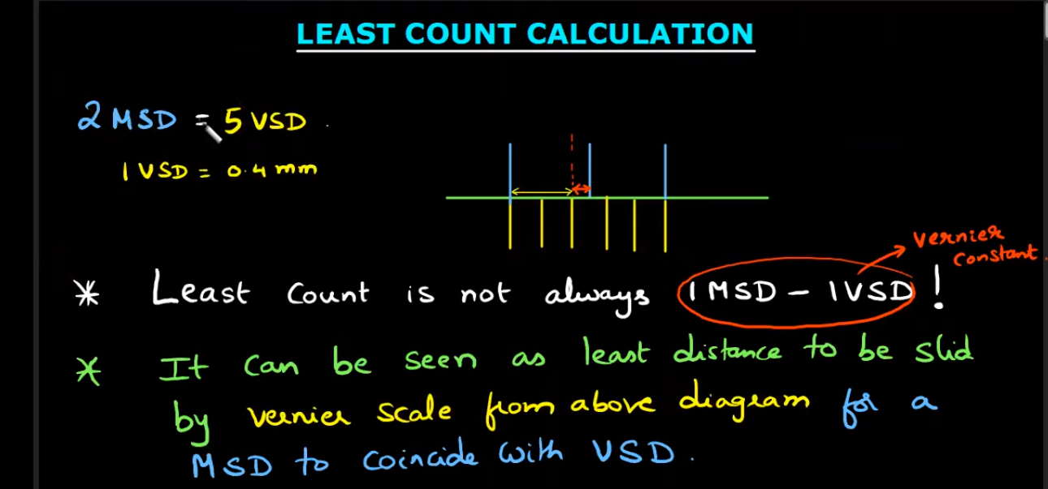
Least Count is not the same as Vernier Constant.
Vernier Constant = 1 MSD – 1 VSD always
Least Count of an instrument is the smallest possible value it can measure accurately.
The least count and the vernier constant are equal only for vernier calipers of the type n MSD = n+1 VSD.

The least count of a vernier caliper is the least distance which must be slid by the vernier scale for a MSD to coincide with the VSD. Since it may not be possible to draw a schematic, to-scale diagram each time, we have the following working rule:
. for m VSDs coinciding with n MSDs where m, n are co-prime, the least count will be 1 MSD/m
. for m VSDs coinciding with n MSDs where m, n are not co-prime, the least count will be 1 MSD/p where (p, q) is the pair obtained by dividing (m, n) repeatedly with their GCDs until two co-prime nos. are obtained

